SafeDispatch solution was successfully implemented in Guatemala City, which is considered the most populous city in Central America, thus representing a difficult challenge in terms of planning, and vehicular traffic control.
Amilcar Montejo, EMETRA (Municipal Transit Authority) in Guatemala “… counting on the best communications technology that can ‘help us’ provide immediate response…” To accomplish this it is imperative to have the best communications technology.
Previously agents had to use multiple communication systems with independent GPS which represented a very high cost for the municipality. EMETRA selected MOTOTRBO radios DGP-6150 and DGP-4150 to be used in a Capacity plus system with 10 repeaters and enhanced GPS.
SafeDispatch Solution
SafeDispatch version 4 of SafeMobile, Inc. was selected as the most effective monitoring and dispatching solution to enhance the capacity of the MOTOTRBO system. Installed modules included; Text Messaging, Reports, GPS with Google Maps and Voice Module and it was configured to monitor over 400 MOTOTRBO units at 2 minutes and 4 minutes intervals. EMETRA’s SafeDispatch system allow them now among various other capabilities to:
- Get accurate on/off reports
-Set and monitor speed limits

-View and replay historic routes
-Create and receive geo-fence alarms
-Sending and receiving text messages
-Receive emergency calls
- Identify and replay calls.
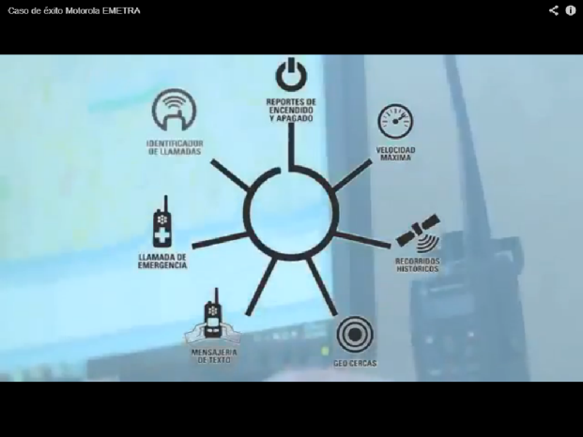
Also, the system included a server and various software dispatcher licenses.
Implementation of the entire project was accomplished in just 10 days and the solution is now in operation in EMETRA’s main monitoring building.
Measurable Results
A significant reduction in costs, great confidence, reliability and useful analysis of automatic information generated by SafeDispatch, increased safety and a seamless integration with MOTOTRBO radio system to create the optimum solution.

